# TEST DATA CREATION

## Postman

Open the API and fill in the headers. Please note to generate token first.

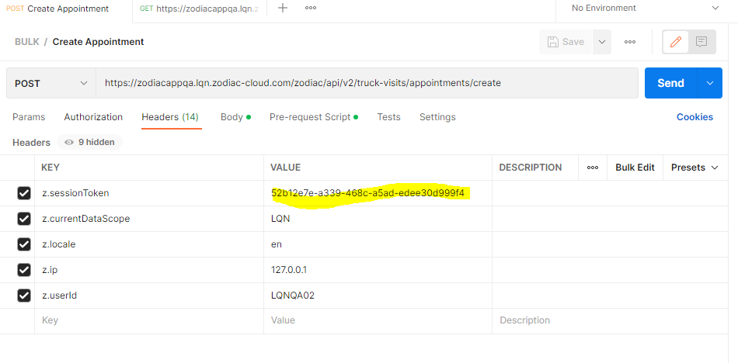

In the Body, instead of setting the values, replace it with the variable enclosed in double curly braces

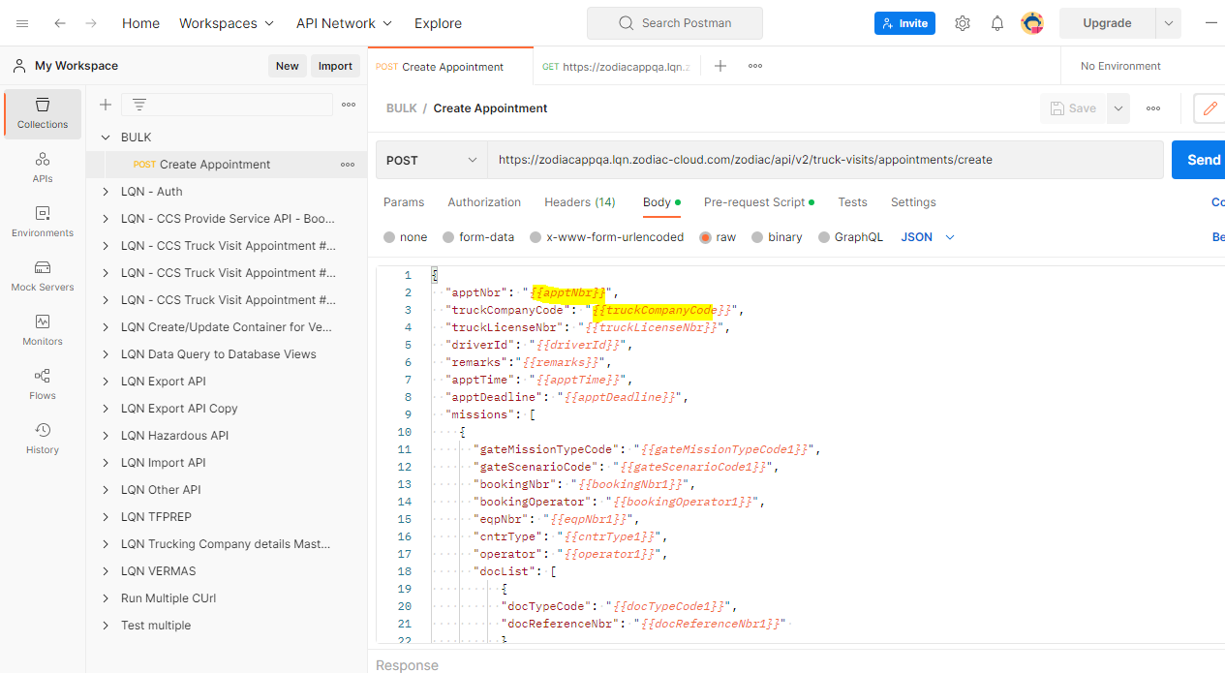

The variable name in the json must be the same as the column name in the csv.

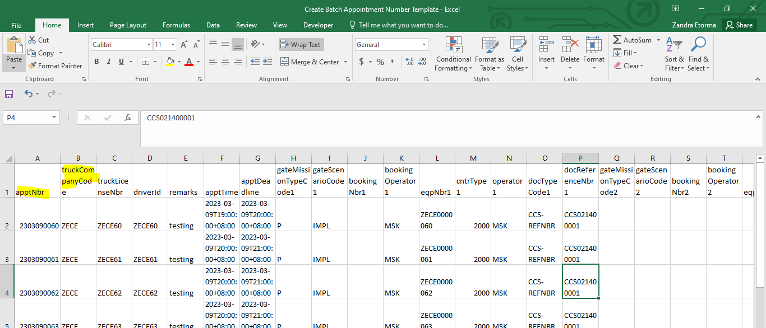

In case you have to create multiple missions (max. of 4) in a single gate visit, can just add new mission in the json with different variable name.

In the example I just added 2 in the variable name.

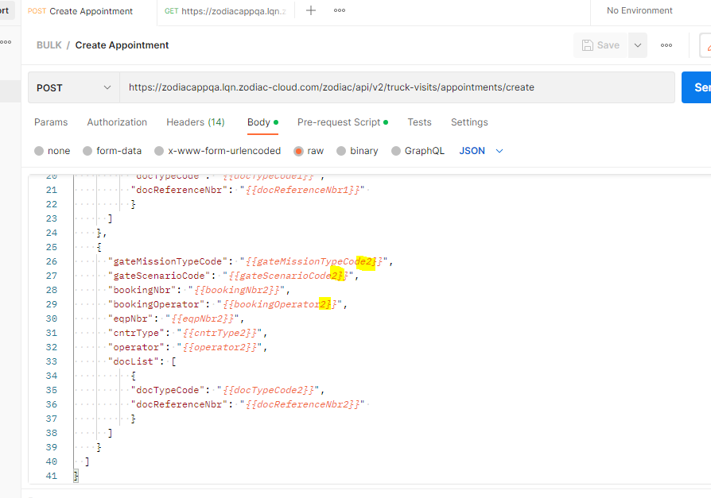

Since I have added mission 2, variables must be added as new columns in the csv as well.

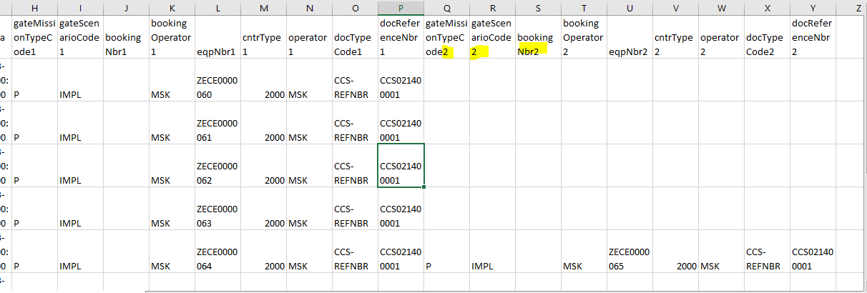

In order for the other 2nd, 3rd or 4th missions to be optional, add a script in the pre-request script to remove 2nd, 3rd or 4th missions if empty

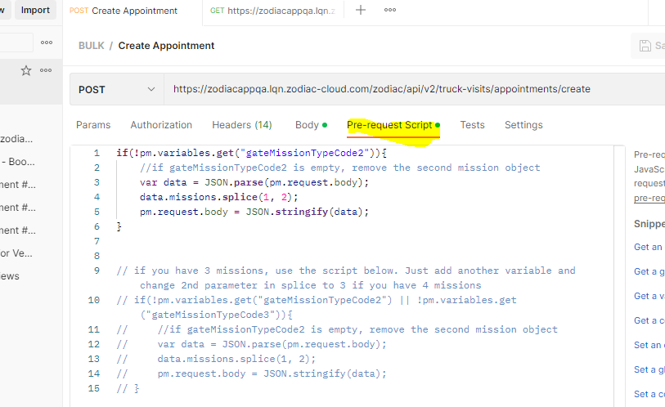

Save all changes.

Go to the collection and select Run Collection from the burger icon.

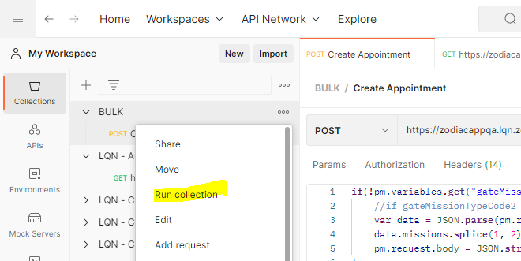

You will be redirected to this page

* Select the item to where the prepared request is located
* Select the prepared csv with data
* The iterations will be automatically populated on how many rows of test data you put in the csv

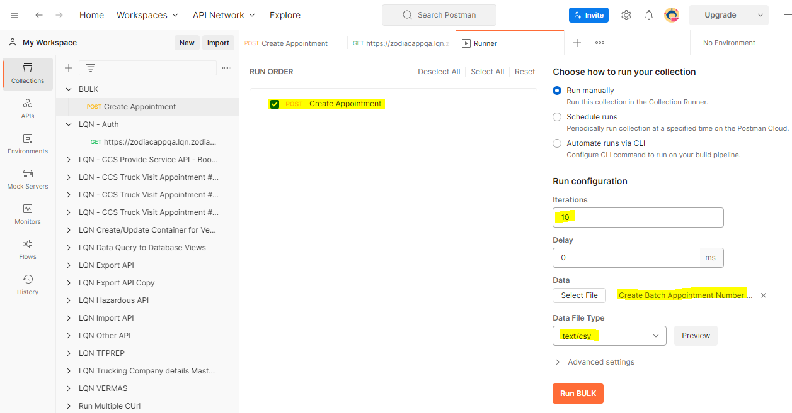

You can click on preview to show the list of test data

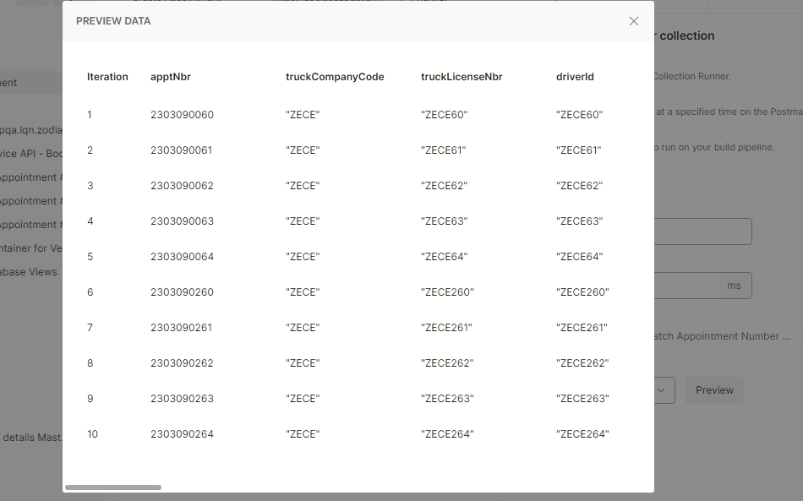

Click on Run Bulk button.

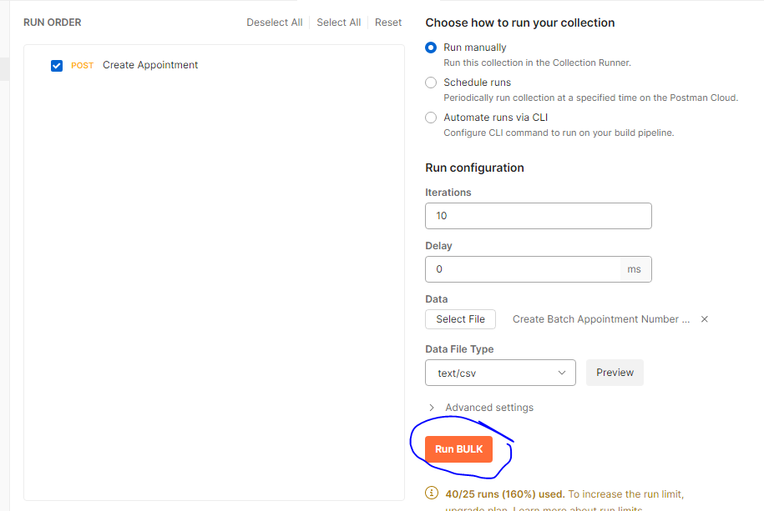

Click on Console button below to see the response. Must be success.

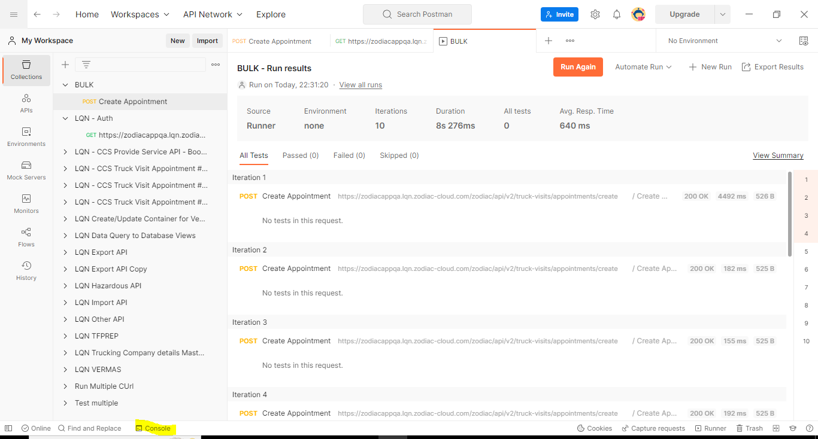

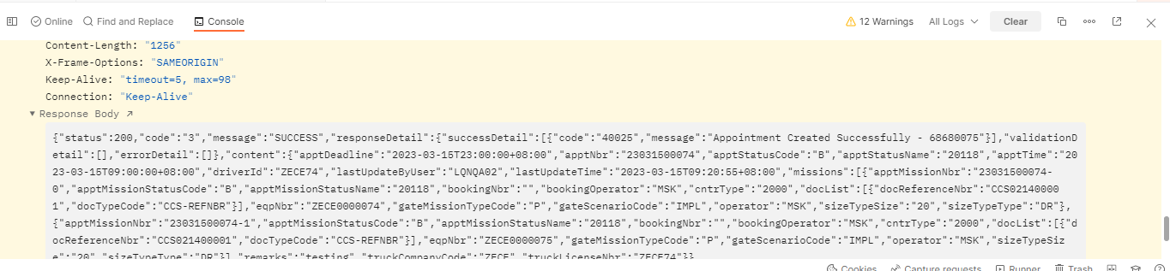

Once you’ve added successfully in the API, you can verify the appointment in the UI.

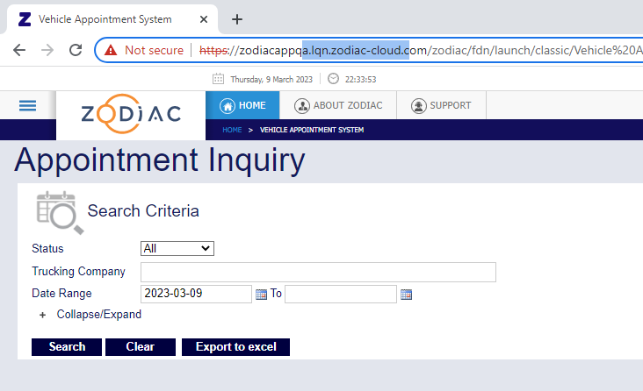

## Test Data in Katalon

There is a template prepared to create the test data to be used in running gate simulation in katalon.

Select which site you are working on in the dropdown. It will automatically display those data that will be using when accessing the site like user, pass etc.

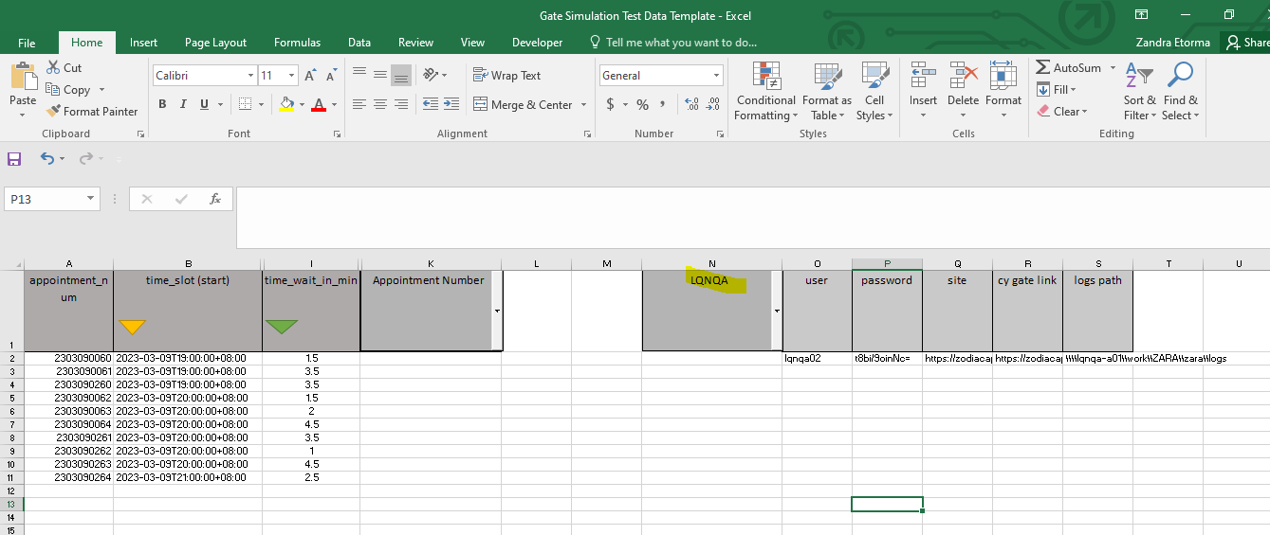

There is another dropdown to where you can select whether to create gate visit via appointment or container number.

If you choose container number in the dropdown, it will show you these required columns.

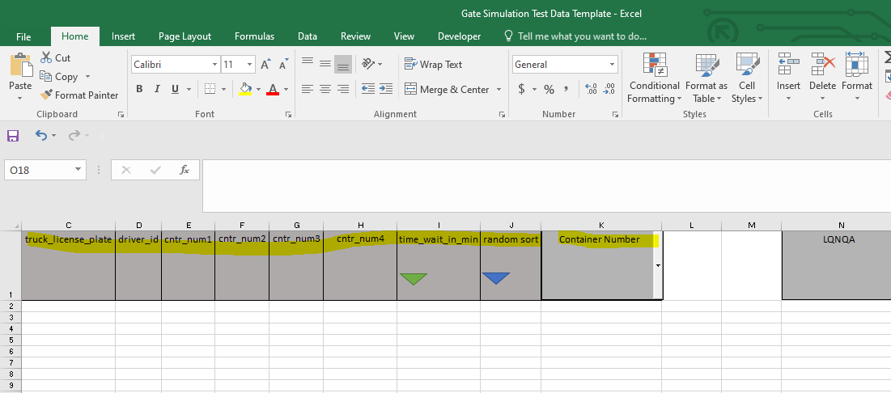

The button in time_wait_in_min will assign random numbers to available rows. It will use as an interval per gate visit.

To change the range of the time_wait_in_min , open the macro and change the range below.

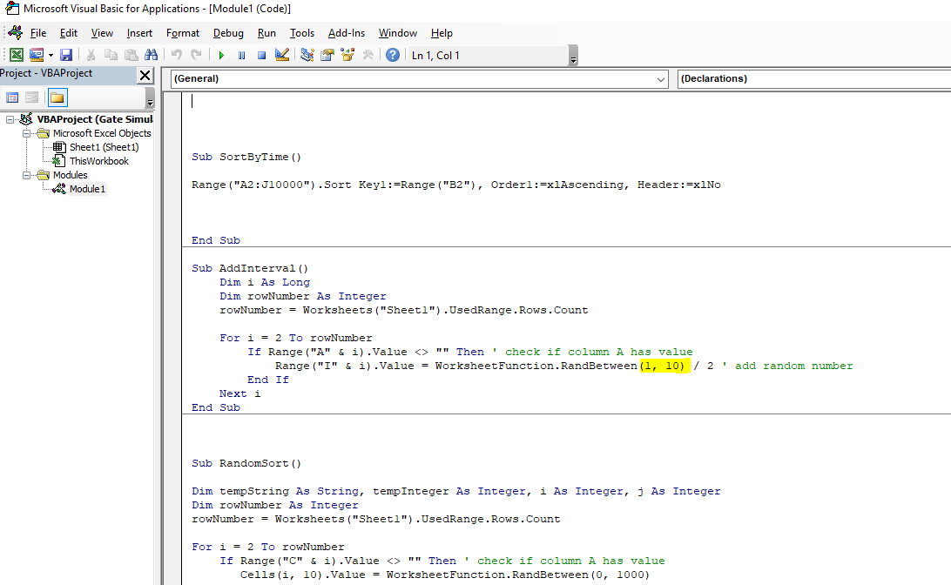

The button in random_sort will assign random numbers to available rows. It will use to randomly sort the containers.

To change the range of the random_sort, open the macro and change the range below.

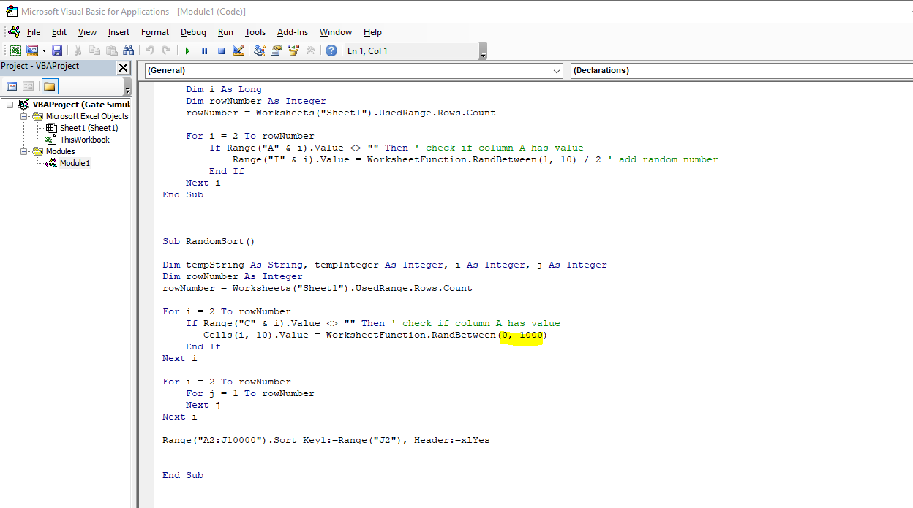

If you choose appointment number in the dropdown, it will show you these required columns.

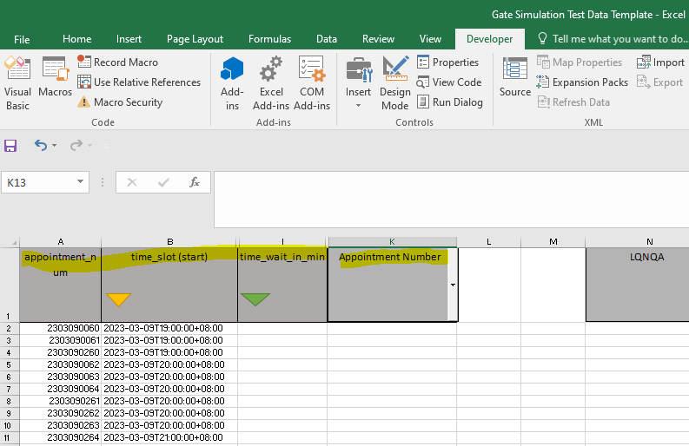

The button in time_slot (start) sort the appointment by time slot.

To add the data, just copy the appointment number and the time start from the csv file used to create the appointment in postman to the test data template for Katalon.

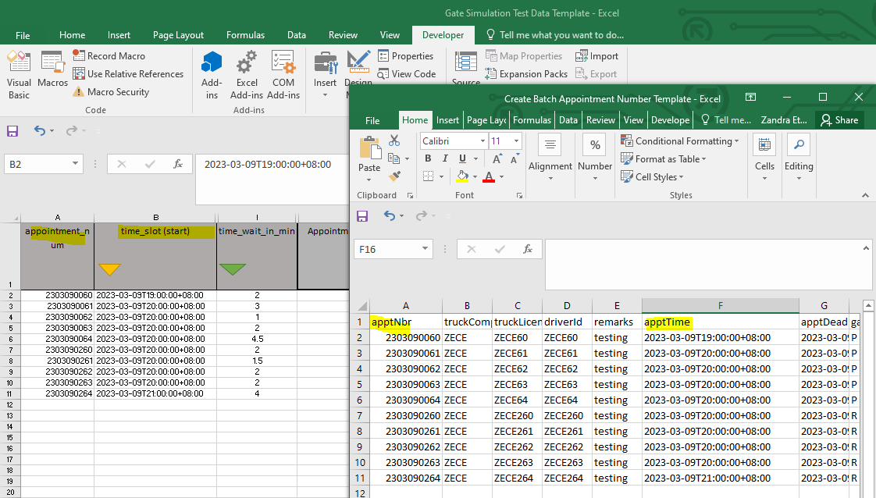

Save the file as Excel Workbook (xlsx) format since the template is in xlsm and katalon only accepts xlsx.

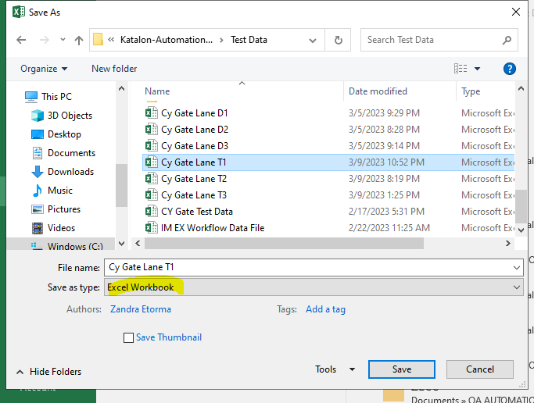

# AUTOMATION RUN

## Configure Katalon

The created test data must be also updated here.

* To create right click to Data Files>New>Test Data
* Browse the test data you created
* Ctrl + S
* Do this to other test data.

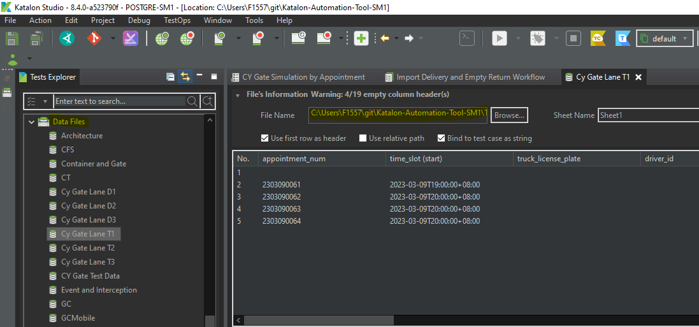

In this Gate Simulation, the In Gate lanes are represented by browser. If you want to open 3 In Gate lanes, you must create 3 test data, 1 for each lane. It can be mixed of IM or EX

For LQNQA, terminal lanes (for full in/out) and depot lanes (for storage) are separated. So better separate those 2 in the template as well in order to use the correct in gate lane.

## Configure the script

This part of the script is configurable by user.

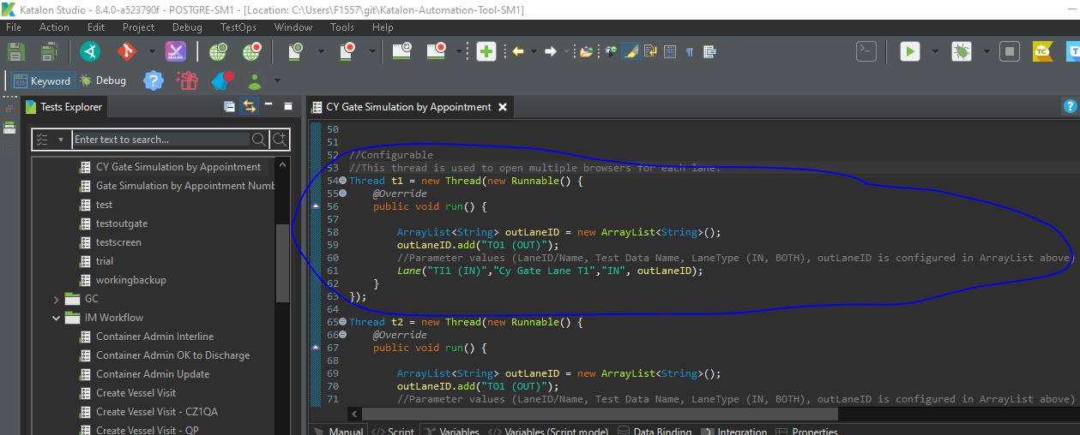

This thread represents the lane. Since I mentioned, browser represent the lane, this will open a browser. If you create another thread, it will open another browser.

To configure each thread and assign your desired lane number, check for the screenshot below.

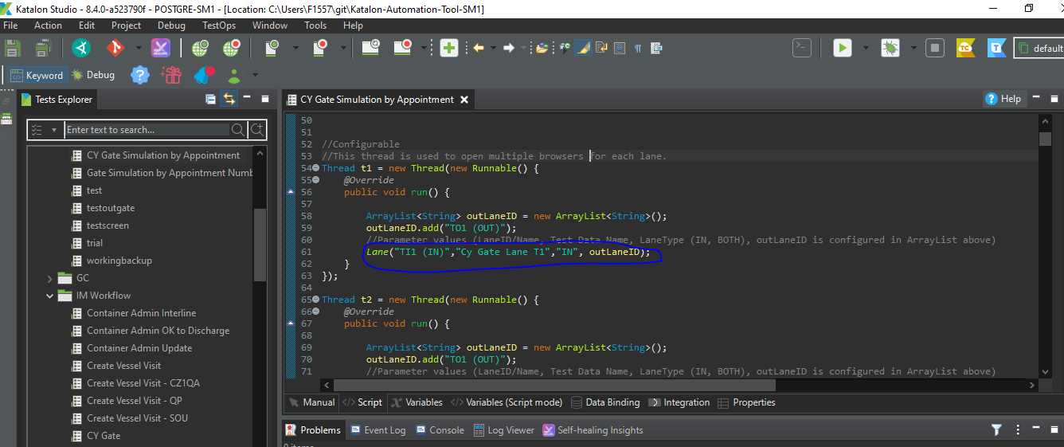

The first parameter will be the name of the in gate lane set in the site. It can be seen when you open CY Gate then select Lane ID. Change the value if what in gate lane you want to use.

The second parameter is the test data file name which I created in the previous steps. Those appointment under the test data will use the in gate lane located in the same thread.

The third parameter, choose between IN and BOTH. I have a condition to which if BOTH, I will no longer select out gate lane since it is already assigned. Else I will assign based on the next parameter which is outLaneID

This the outLaneID parameter, you can add the out lane ID you want to gate out the truck from this thread. In case you added two from the list, it will shuffle and just select the index 0 or the first lane.

After this, you can just copy the thread, set unique thread name and change the parameters to make another lane.

Once you added all lane, start the thread using this syntax.

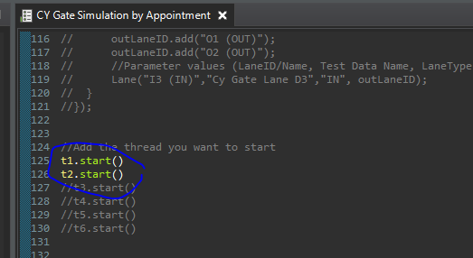

## How the Gate Simulation Works?

One you started the automation, the browsers open for in gate lanes will create the gate visit simultaneously. Once the container is lifted on or off in the OPS, it will generate gate visit log. The log will be the basis for the automation to know if the gate visit is ready to out gate. Once ready, it will open another browser for out gate. One browser per gate visit for each out gate but once done with the out gate, the browser will close. All of these process can be done simultaneously.

## Limitations

* Since we are using multithread to simultaneously run the lanes to different browser, the processes take more resources. So the performance depends on the hardware specification. It might slow down the process or it might not work properly.
* This is only used for creating gate visit by appointment number in CY Gate for now.
* Even the script is configurable, it still might not work on other site due to the following:
  + Xpath of the elements are not the same as the basis (LQNQA)
  + Process might not be the same like how many gates to proceed

## Scenarios to take note:

* Can support up to 4 missions (1EX, 1IM, 1 Empty Return, 1 Empty Pickup)
  + If this is the scenario, it will wait for all the logs (by container) to be available before gate out
  + Above scenario won't be use in LQNQA due to Empty and Full Gates are separated but it is still supported and it won't be an issue. If you use it, it will just select the out gate number to where you put the test data (customize parameter available in the script). For example you put all for to test data 1 then add O1 (OUT). It will out gate to that even though that gate is for EMPTY only.

* Start time of the appointment is being compared to the current time. The scripts reads the time slot column in the test data template and add 60 minutes to create a range.
  + If the appointment start time is expired, it will not skip it and proceed to the next row.
  + If the current time is within the appointment time range, it will proceed in the creation.
  + If the current time is not yet within the appointment range, it will get the remaining time by subtracting current time to start time, then it will sleep depending on the remaining time. Once the remaining time is reached means the appointment is already within the time, it will proceed. It will not skip so remember to always click the sort time slot in the excel template.
* In case the site has 3 out gate lanes, it will just shuffle and select the first one. List of out gate must be added in the customize parameter in the script
* Only gate visit with FULL/EMPTY OUT missions will be gated out since IN missions are automatically completed after lift
* Remember when running the script, it will terminate all chrome browsers and drivers that are running for better performance. If don't want to, just comment out these 2 lines in the script

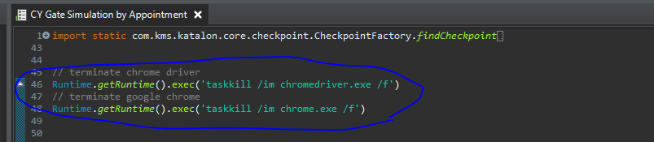

## See prepared video for the running of the gate simulation in Katalon.